Training Day – 33

Topic:* Scatter Plots in Matplotlib

* Plotted relationships between two variables.
* Example: Visualized correlation between "Age" and "Height" columns.

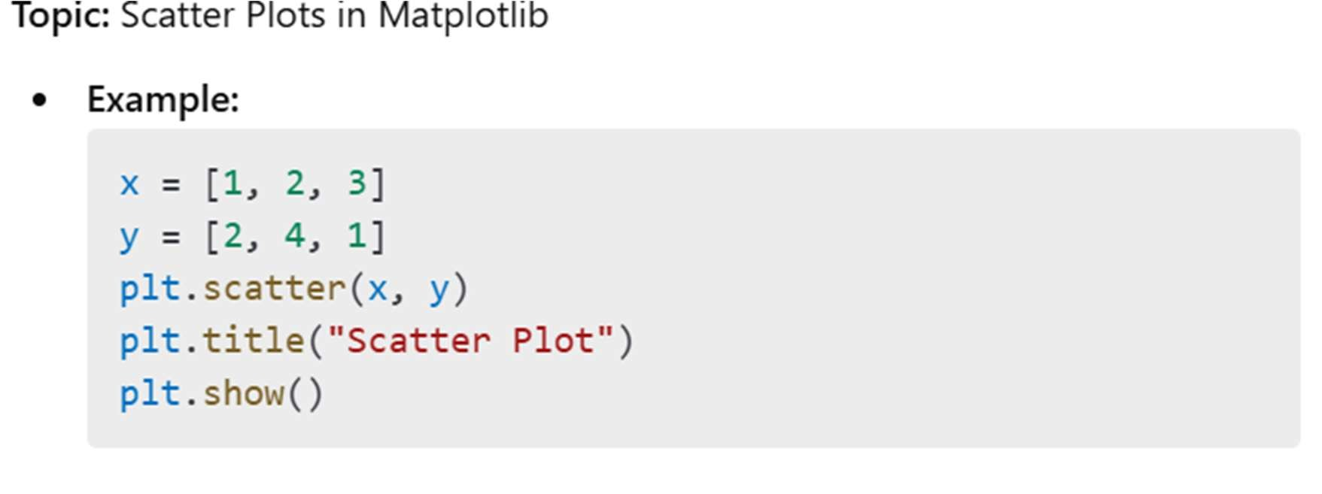

visualization easier and identifying outliers easily.

1.IQR: It stand for "inter quartile range", which define as the difference of "third quartile(q3) and first quartile (q0)".

* 1. Outliers are those value which comes after the last quartile to affect our mean, as well as below the first quartile.
  2. Our whole data is divided in four part i.e. 25%, 50%, 75%, 100%, and these percentile values refers to our quartile(q1,q2,q3,q4).

4.The value of lower_limit is extracted by applying formula of lower_limit = q1-1. 5*(IQR). The value of upper_limit is extracted by applying formula of upper_limit=q3+1.5*(IQR).

